Name: _________________________________ Period: _______ Date: _________________________
Book Title: ______________________________ Author: _______________________ Pages: _______
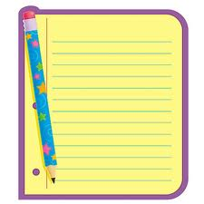
Interactive Notes
Directions: During reading day, write something for each of the following sections: Before Reading, During Reading, and After Reading. Use one of the sentence starters or questions to respond in each section. WRITE USING COMPLETE SENTENCES.
Before Reading | During Reading | After Reading
* What can I predict about the book by looking at the front cover?  * What can I predict about the book by reading the back cover?  * One question I have before reading today is…because…  * Why did I choose to read this book?  * I predict The main character will need or want…because…  * A question I have is…  * I think this book is about… | * I wonder why…  * What caused…  * I think…  * Why does the main character act or feel a certain way?  * I think the main character…  * This reminds me of…  * What do they mean by…  * What I find confusing is…  * What I think will happen next is…  * This is important because…  * I can relate to this because… | * Three important points/ideas are…  * This is important because…  * I think the author wants me to think about…  * At this point, the book is about…  * I still don’t understand…  * A good word to describe this book is…because…  * This book makes me feel…  * I like this book because…  * I dislike this book because…  * My favorite part about what I read today is…  * My feelings about the main character are…
Use complete sentences in your response. Write at least 10 words, not including the prompt. | Use complete sentences in your response. Write at least 15 words, not including the prompt. | Use complete sentences in your response. Write at least 15 words, not including the prompt.

Write the three most important events or facts you read about today. Use complete sentences.
1.

2.

3.

